Software Requirements Specification
for
<HOTEL MANAGEMENT SYSTEM>
Version 1.0 approved
Prepared by <G Rithesh Varma,
Ch Vishnu Vardhan>,
Ch S N Praveen,
E H V D Prasad,
Nikhil P>

<5-9-2018>
Table of Contents
Table of Contents ii
Revision History ii
1. Introduction 1
1.1 Purpose 1
1.2 Document Conventions 1
1.3 Intended Audience and Reading Suggestions 1
1.4 Product Scope 1
1.5 References 1
2. Overall Description 2
2.1 Product Perspective 2
2.2 Product Functions 2
2.3 User Classes and Characteristics 2
2.4 Operating Environment 2
2.5 Design and Implementation Constraints 2
2.6 User Documentation 2
2.7 Assumptions and Dependencies 3
3. External Interface Requirements 3
3.1 User Interfaces 3
3.2 Hardware Interfaces 3
3.3 Software Interfaces 3
3.4 Communications Interfaces 3
4. System Features 4
4.1 System Feature 1 4
4.2 System Feature 2 (and so on) 4
5. Other Nonfunctional Requirements 4
5.1 Performance Requirements 4
5.2 Safety Requirements 5
5.3 Security Requirements 5
5.4 Software Quality Attributes 5
5.5 Business Rules 5
6. Other Requirements 5
Appendix A: Glossary 5
Appendix B: Analysis Models 5
Appendix C: To Be Determined List 6

Revision History
Name | Date | Reason For Changes | Version
Change 01 | 09-10-2018 | Changes in System requiements | 2.0

Introduction

Purpose
Our project is Hotel management system. The motive to do this project is to provide a base for the foundation of the project. And to make the client work simple. It gives an overall view of the hotel and what is happening in the hotel Customers expectations and requirements are analyzed to produce according to their requirement. The main reason to do was as the hotels are very common in every town and city so to reduce the manual work and decrease the waiting time and make the work as simple as possible.

Document Conventions
- <Bold> – Headings
- <Arial>-For description

Intended Audience and Reading Suggestions
The document is intended for developers, project managers, users and documentation writers
The rest of the SRS part describes the features of this project if you want to know the features of the project you can skip the introduction part.

Product Scope
The software product to be produced is a hotel management system which is used to do the all the works of hotel which were required by the user some of the subsystems of this project are to generate the bills and dates of check in and check out, etc more to come.
This project is used for those users with hotel more than 30 rooms then the work they do becomes simple while compared top their manual work.

Reference
There are no references until now.

Overall Description

Product Perspective
The project was taken because of the clients request as the user was known to us as he uses to say the disadvantages of manual work and what he was facing with so to overcome such problems and make the user work simple this product was made as we made analysis on the different hotels so that we can get different problems and make their solution and the solution is our project.

Product Functions
- Booking of the room
- To show to the user where to give the room to customer
- Details of the rooms which were filled and which were vacant
- details of the customer present in the room checked I and out details personal details etc
- Orders of customer
- Bills will be generated on a single button click
- when the customer checks out the room the total amount which he has to pay is displayed
- when no rooms are available and a customer would like to extend their reservation their information will be placed in a database and when there are rooms available the first customer on the list will have the room

User Classes and Characteristics
Classes:
- Manager
the manager class contains all permissions to access the data
- Staff

Design and Implementation Constraints
The following product is going to be built on windows 10 platform.
the product can be installed on any windows platform which should require the following minimum hardware implementations:
- RAM:512 MB
- ROM:50 GB

User Documentation
This product is limited to only staff and manager of the hotel and it will be a limit for customers
developers had to build this project restricting to offline implementation.
Software used:
- Netbeans IDE
- MySql DataBase
- XML GUI
the security of the data is maintained as it is accessed by administrators only.

Assumptions and Dependencies
There are no such user manuals as it is not for customers but we’ll be having a documentation for the operation of the software which will be helpful for the computer employee to handle the application software.

Assumptions and Dependencies
It may happen that the hotel may want the application to be online in due time where only offline application was proposed. the constraints may exclude to per-booking of the tables in the hotel restaurant itself.

External Interface Requirements

User Interfaces
Hotel Payment Accept payment for room and food Room Service/Restaurant Create order, modify order, view order, cancel order, generate meal bill Customer Record Add or update customer records Administer Rooms Availability and rates Administer User Create, modify, and delete users; change password Administer Meals Create, modify, and delete meal items and prices Reports Select, view, save, and delete reports

Hardware Interfaces
There is no special type of Hardware required for this System.

Software Interfaces
The system shall interface with an Oracle or Access database.

Communications Interfaces
The system shall be a standalone product that does not require any communication interfaces

System Features
  - Functional Requirements

All the features of the proposed System are provided in a tabular format below:

Feature | Description | ID | Functional Requirement
login | It improves security so that only authorized can access the data. | 1 | Username and password
Check rom availability | It tells how many rooms are available | 2 | Room details
Book room | Allots the customer the required no of rooms | 3 | Room details
Show food menu | Shows the menu as per that day’s menu | 4 | Show()
Order food | Books the menu as per the requirement of the customer | 5 | TBD
Laundry services | Collects the total information for which laundry is used and updates the bill | 6 | TBD
Log of the customers | Shows how many customers are in hotel in that particular day | 7 | Username and password
Checkout | Generates a final bill for the customer | 8 | confirm
Employee info | Only Manager can access data of that particular employee | 9 | Username and password
Payment of the customer | Whether payment is done by cash or card | 10 | TBD
Room evacuation | To empty room and add it to existing empty rooms | 11 | Username and password
Attendance marking | To know whether an employee is present on particular day or not | 12 | Username and password
Update food menu | Update the food menu as per requirements | 13 | Administrator authentication
Update prices of the particulars | To update the prices of the transport or laundry or rooms etc | 14 | Administrator authentication

4.1 Login
Description:
Employee needs to login to do any action in the application.
Stimulus:
This feature provide access to different parts I the application like booking a room, generating checkouts, laundry services, etc.
Functional Requirements:
The Functional Requirements in this feature are:
An employee is provided with:
1. Username
2. Password associated with that particular username
Any wrong entry in the above functional requirements would lead to an error message displayed on the Screen.

Check Room Availability

Description
This feature provides about the information of rooms that are open for booking in the hotel

Stimulus
On clicking on this feature, a message window popups giving the details of the empty rooms in the hotel

Functional Requirements
There are no functional Requirements required for this feature. Anyone can access this feature in the application

Book Room

Description
Whenever a room is to be booked, this feature comes in handy, such that an employee allocates the room to a customer in this feature.

Stimulus
As soon as this feature is accessed, a new window opens which prompts for the employee’s login details. After Successful login a window opens which contains the options for booking rooms like single double duplex etc.

Functional Requirements
The Functional Requirements in this feature are:
An employee is provided with:
1. Username
2. Password associated with that particular username
Any wrong entry in the above functional requirements would lead to an error message displayed on the Screen.

Show Food Menu

Description
This feature shows the menu for that present day in the hotel

Stimulus
This feature provides an option for the customer to view the food menu that is being served in the hotel for that current day he can choose two different menus ie veg or non veg depending upon his interest and choose his order accordingly

Functional Requirements
There are no functional Requirements required for this feature. Anyone can access this feature in the application.

Book Food

Description
This feature provides the access for the employee to enter the orders booked by the customer.

Stimulus
A new window opens after clicking on this feature, which prompts for the employee to enter his login credentials to access after window. After successful login, there will be a window, which asks the employee to enter the orders booked by the customer so as to save that data in the database

Functional Requirements
The Functional Requirements in this feature are:
An employee is provided with:
1. Username
2. Password associated with that particular username
Any wrong entry in the above functional requirements would lead to an error message displayed on the Screen.

Laundry

Description
This feature collects the information about number of clothes given to laundry by that particular customer and updates the bill.

Stimulus
On clicking this a new window opens up and collects the information about of number of clothes for each cloth type and updates the bill for that customer in the database.

Functional Requirements
The Functional Requirements in this feature are:
An employee is provided with:
1. Username
2. Password associated with that particular username
Any wrong entry in the above functional requirements would lead to an error message displayed on the Screen.

Log Of Customers

Description
This feature gives the information of total number of customers which are present in hotel at that particular day.

Stimulus
Accessing this feature opens a window that prompts the administrator to authenticate to
.after authentication there will be a window displaying the records of the customers on that particular date

Functional Requirements
It requires Administrator login authentication to access the data for the log
The administrator will be given with
1.Username
2. Password associated with particular username to access the data for the log.
Any wrong entry in the above functional requirements would lead to an error message displayed on the Screen.

Checkout

Description
This system feature generates the total bill made up by that particular customer

Stimulus
On accessing this feature the application prompts for the employee’ login details.After successful login there will be a windows which provides options for the employee to generate the bill for that particular customer

Functional Requirements
The Functional Requirements in this feature are:
An employee is provided with:
1. Username
2. Password associated with that particular username
Any wrong entry in the above functional requirements would lead to an error message displayed on the Screen

Employee Info

Description
This feature displays the details of a particular employee and only accessed by the manager

Stimulus
On accessing this feature, opens a window prompting the administrator to authenticate with the database. After successful authentication, there will be a window opened displaying all the names of the employees in the hotel and when clicked on a particular name it gives all the details of that particular employee

Functional Requirements
It requires Administrator login authentication to access the data for the log
The administrator will be given with
1.Username
2. Password associated with particular username to access the data for the log.
Any wrong entry in the above functional requirements would lead to an error message displayed on the Screen.

Payments

Description
The manager or employee takes the details of the customer payment’s method.

Stimulus
This feature opens a new window showing two radio buttons cash and card and update the details to database of that particular customer

Functional Requirements
The Functional Requirements in this feature are:
An employee/administrator is provided with:
1. Username
2. Password associated with that particular username
Any wrong entry in the above functional requirements would lead to an error message displayed on the Screen

Room evacuation

Description
This feature gives access to an employee to evacuate the room which is booked by a customer.

Stimulus
On using this feature, it opens a new window asking for a room number and when the details are entered that particular room type (single, double, duplex) record is going to update in the database showing that the room is available for future booking. Before the room is being evacuated the application prompts the employee whether checkout has been completed or not with a warning message form.

Functional Requirements
The Functional Requirements in this feature are:
An employee is provided with:
1. Username
2. Password associated with that particular username
Any wrong entry in the above functional requirements would lead to an error message displayed on the Screen

Attendance

Description
The manager must mark the attendance of employee to check whether he is present on a particular day or not.

Stimulus
On clicking this Attendance button a new window opens up listing all the employee name and each employee name has two radio buttons present or absent

Functional Requirements
It requires Administrator login authentication to access the data for the log
The administrator will be given with
1.Username
2. Password associated with particular username to access the data for the log.
Any wrong entry in the above functional requirements would lead to an error message displayed on the Screen.

Update Food Menu

Description
This feature provides an option for the hotel to make changes in the food menu as per requirements.

Stimulus
This feature requires an authentication from the administrator, which opens a window to change a menu item in the database to replace older and upload newer one.

Functional Requirements
It requires Administrator login authentication to access the data for the log
The administrator will be given with
1. Username
2. Password associated with particular username to access the data for the log.
Any wrong entry in the above functional requirements would lead to an error message displayed on the Screen.

Price Updation

Description
This feature enables the manager to update or change the pricing of different particulars in the application like laundry , room , etc

Stimulus
This feature requires the administrator authentication. After that a window opens up and which contains the options for the manager to change of prices in new fields.

Functional Requirements
It requires Administrator login authentication to access the data for the log
The administrator will be given with
1. Username
2. Password associated with particular username to access the data for the log.
Any wrong entry in the above functional requirements would lead to an error message displayed on the Screen

Other Nonfunctional Requirements

Performance Requirements
- This System will work fast comparatively
- data in the database can be accessed, changed or retrieved very soon.

Safety Requirements
The Staff or Manager of the Hotel must be careful while entering the data like booking of rooms, booking the food, laundry services etc., into database as this system is input based system so that there can be no errors in the final bill at the time of checkout.

Security Requirements
All the customer details which are stored in the database can only be accessed by the Manager or other who are authorized with the use of special login id and password which is granted only to the Manager and no other staff or customer shall access it.

Software Quality Attributes
This System is easy to maintain and use.

,
Appendix A: Glossary
Netbeans: it is an IDE on which the backend coding will be done (generally) for the proposed application
XML: it is the graphical user interface for the app on which it runs.it is basically the front end of the application
MySql: It is the database on which all the data regarding the customers and employee data is stored

Appendix B: Analysis Models
B.1 Use Case Diagram
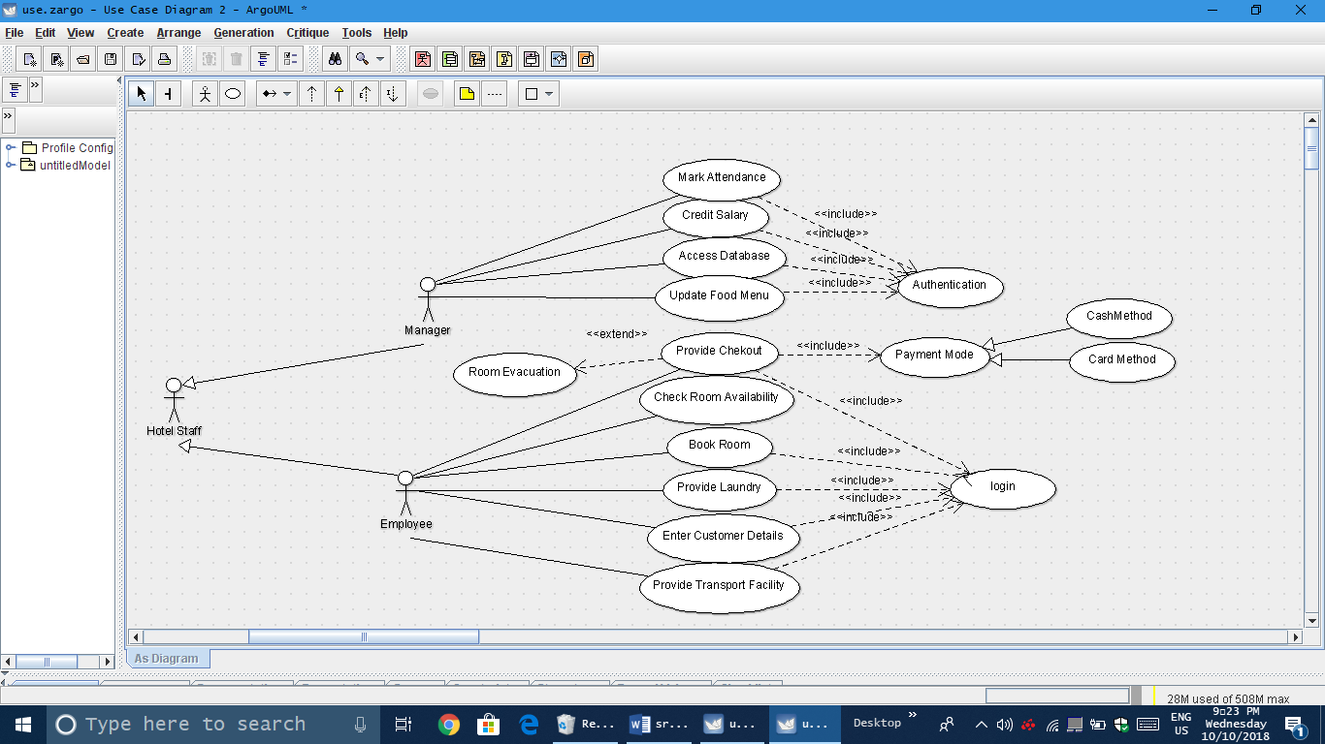

Appendix C: To Be Determined List
- To be determined list will increase in course of the project as per requirements and the obligations of the customer.
- Functional requirements will be added in course of the project.

